|  |  |  |  |
| --- | --- | --- | --- |
|  | **COLLEGE OF COMPUTING AND INFORMATION SCIENCES** | | |
| **Assignment # 01** | | |
| **Course Title** | Programming Fundamental | **Total Marks** | 10 |
| **Date** | 20-11-2022 | **Class ID** | 110803 |
| **Student Id** | 65309 | **Student Name** | SOHAIB ANJUM |

CSS:

body{

    background-color: white;

    text-align: center;

}

nav{

    height:100px;

    width:100% ;

    background-color: red;

    text-align: center;

}

<!DOCTYPE html>

<html lang="en">

<head>

<meta charset="UTF-8">

<meta http-equiv="X-UA-Compatible" content="IE=edge">

<meta name="viewport" content="width=device-width, initial-scale=1.0">

<link rel="stylesheet" href="style.css">

<title>khokhar steel Home </title>

</head>

<body>

<header class="header">

<nav>

<div class="navigation"><a href="html.html"> <img src="logo.png" height="80px" width="35%" style="float: left;margin-top: 5px;"></a>

</div>

<div class="tabs" style="float: left;margin-top: 50px;" >

<a href="html.html" style="color:white;float: left;margin-left: 50px;text-decoration: none"> HOME </a>

<a href="Products.html" style="color:white;margin-left: 5px;text-decoration: none">PRODUCTS</a>

<a href="about.html" style="color:white;margin-left: 5px;text-decoration: none">ABOUT US </a>

<a href="services.html" style="color:white;margin-left: 5px;text-decoration: none">SERVICES </a>

<a href="clients.html" style="color:white;margin-left: 5px;text-decoration: none">OUR CLINTS </a>

<a href="contact.html" style="color:white;margin-left: 5px;text-decoration: none">CONTACT US </a></div>

</nav>

</header>

<h1> Our Feature Products</h1>

<div style="height: 220px;width: 170px; border-style: solid;border-width: 2px;border-radius: 10%;margin-left: 100px;float: left;">

<img src="3.1p.jfif" height="75%" width="100%" style="border-top-right-radius: 10%;border-top-left-radius: 10px;" >

<div style="float: left;">digital files<br> resistance<br> safe</div>

<div style="background-color: red;float: left;height: 55px;width: 85px;;margin-top: -2%;border-top-left-radius: 20%;border-bottom-right-radius: 21%;margin-left: 7.25%;">Model<br> DRFS 600</div>

</div>

<div style="height: 220px;width: 170px; border-style: solid;border-width: 2px;border-radius: 10%;margin-left: 50px;float: left;">

<img src="3.2p.jfif" height="75%" width="100%" style="border-top-right-radius: 10%;border-top-left-radius: 10px;" >

<div style="float: left;">digital Safe<br> Locker</div>

<div style="background-color: red;float: left;height: 55px;width: 85px;margin-top: -2%;border-top-left-radius: 20% ;border-bottom-right-radius: 21%;margin-left: 6.75%;">Model<br> EG25</div>

</div>

<div style="height: 220px;width: 170px; border-style: solid;border-width: 2px;border-radius: 10%;margin-left: 50px;float: left;">

<img src="3.3p.jfif" height="75%" width="100%" style="border-top-right-radius: 10%;border-top-left-radius: 10px;" >

<div style="float: left;border-width: 50%;">digital Safe<br> Locker</div>

<div style="background-color: red;float: left;height: 55px;width: 85px;;margin-top: -2%;border-top-left-radius: 20%;border-bottom-right-radius: 21%;margin-left: 6.75%;">Model<br> MB 2045</div>

</div>

<div style="height: 220px;width: 170px; border-style: solid;border-width: 2px;border-radius: 10%;margin-left: 50px;float: left;">

<img src="pal.jfif" height="75%" width="100%" style="border-top-right-radius: 10%;border-top-left-radius: 10px;" >

<div style="float: left;">Palet racks</div>

</div>

<div style="width: fit-content;margin-left: 35%;margin-top: 300px;"><h2 style="margin-top: 10px;">Fire & Theft resistance Safe</h2></div>

<small style="color: gray;margin-top: 5px;">we have very wide fire & theft resistance sefes. Some images of fire &<br> theft resistance safe is showing below</small>

<div style="height: 60%;width:100%;">

<img src="3.1p.jfif" height="200px" width="200px" >

<img src="3.2p.jfif" height="200px" width="200px" >

<img src="3.3p.jfif" height="200px" width="200px" >

<img src="3.4p.jfif" height="200px" width="200px" >

<img src="3.5p.jfif" height="200px" width="200px" >

<img src="3.6p.jfif" height="200px" width="200px" >

<img src="3.8.jfif" height="200px" width="200px" >

<img src="3.7.jfif" height="200px" width="200px" ></div>

<h1>Clients</h1><div style="margin-top:50px;">

<div style="float: left;margin-top: 15%;margin-left: 5%;"> <h1>Our Key Clients</h1><small>Our Clients come from cutting edge competative <br>privite companies with strong organic growth</small></div>

<div style="height:960px;width: 65%;float: right;">

<div style="float: left;"> <img src="nbp.png" height="180px" width="200px"> </div>

<div style="float: left;"> <img src="dg.png" height="180px" width="200px"> </div>

<div style="float: left;"> <img src="lkc.png" height="180px" width="200px"> </div>

<div style="float: left;"> <img src="tcs.png" height="180px" width="200px"> </div>

<div style="float: left;"> <img src="psm.jfif" height="180px" width="200px"> </div>

<div style="float: left;"> <img src="dha.jfif" height="180px" width="200px"> </div>

<div style="float: left;"> <img src="parco.jfif" height="180px" width="200px"> </div>

<div style="float: left;"> <img src="ffc.jfif" height="150px" width="200px"> </div>

<div style="float: left;"> <img src="drzia.jpg" height="200px" width="200px"> </div>

</div>

</div>

</body>

</html>

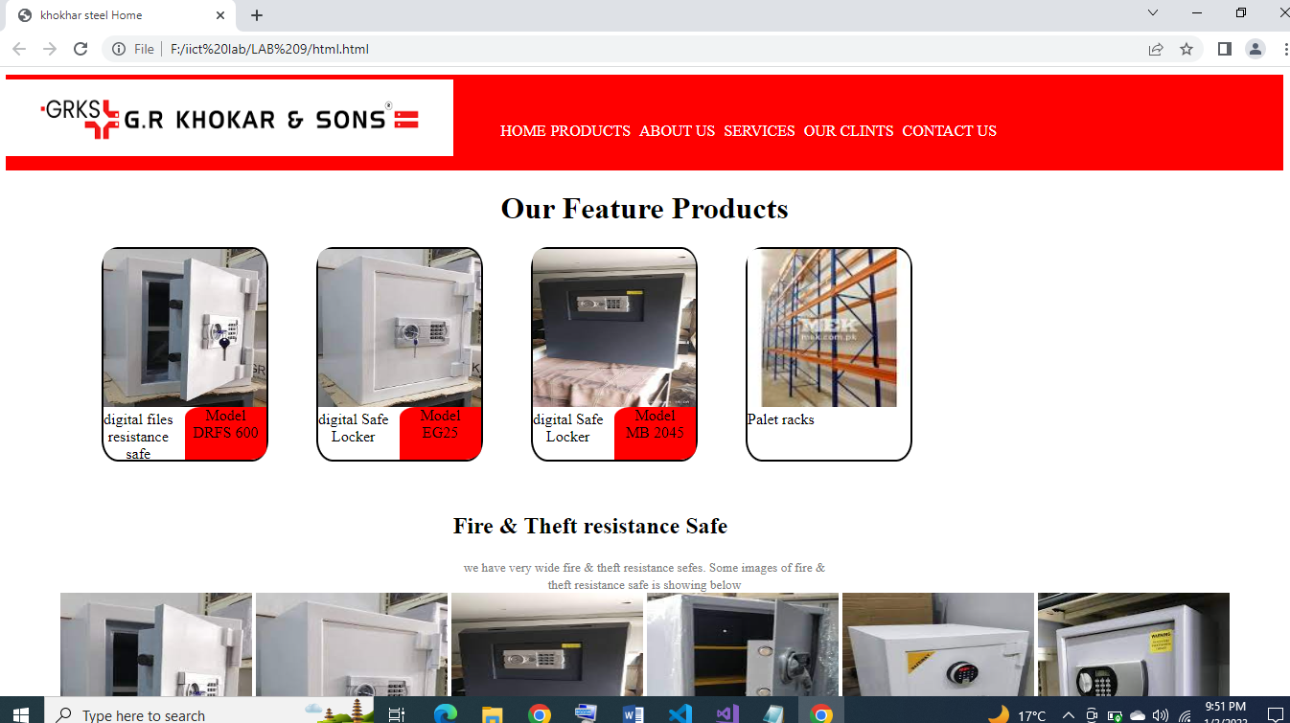

<!DOCTYPE html>

<html lang="en">

<head>

<meta charset="UTF-8">

<meta http-equiv="X-UA-Compatible" content="IE=edge">

<meta name="viewport" content="width=device-width, initial-scale=1.0">

<link rel="stylesheet" href="style.css">

<title>Products</title>

</head>

<body>

<header class="header">

<nav>

<div class="navigation"><a href="html.html"> <img src="logo.png" height="80px" width="35%" style="float: left;margin-top: 5px;" ></a>

</div>

<div class="tabs" style="float: left;margin-top: 50px;" >

<a href="html.html" style="color:white;float: left;margin-left: 50px;text-decoration: none;"> HOME </a>

<a href="Products.html" style="color:white;margin-left: 5px;text-decoration: none">PRODUCTS</a>

<a href="about.html" style="color:white;margin-left: 5px;text-decoration: none">ABOUT US </a>

<a href="services.html" style="color:white;margin-left: 5px;text-decoration: none">SERVICES </a>

<a href="clients.html" style="color:white;margin-left: 5px;text-decoration: none">OUR CLINTS </a>

<a href="contact.html" style="color:white;margin-left: 5px;text-decoration: none">CONTACT US </a></div>

</nav>

</header>

<h1> Our Feature Products</h1>

<div style="height: 220px;width: 170px; border-style: solid;border-width: 2px;border-radius: 10%;margin-left: 100px;float: left;">

<img src="3.1p.jfif" height="75%" width="100%" style="border-top-right-radius: 10%;border-top-left-radius: 10px;" >

<div style="float: left;">digital files<br> resistance<br> safe</div>

<div style="background-color: red;float: left;height: 55px;width: 85px;;margin-top: -2%;border-top-left-radius: 20%;border-bottom-right-radius: 21%;margin-left: 7.25%;">Model<br> DRFS 600</div>

</div>

<div style="height: 220px;width: 170px; border-style: solid;border-width: 2px;border-radius: 10%;margin-left: 50px;float: left;">

<img src="3.2p.jfif" height="75%" width="100%" style="border-top-right-radius: 10%;border-top-left-radius: 10px;" >

<div style="float: left;">digital Safe<br> Locker</div>

<div style="background-color: red;float: left;height: 55px;width: 85px;;margin-top: -2%;border-top-left-radius: 20%;border-bottom-right-radius: 21%;margin-left: 6.75%;">Model<br> EG25</div>

</div>

<div style="height: 220px;width: 170px; border-style: solid;border-width: 2px;border-radius: 10%;margin-left: 50px;float: left;">

<img src="3.3p.jfif" height="75%" width="100%" style="border-top-right-radius: 10%;border-top-left-radius: 10px;" >

<div style="float: left;border-width: 50%;">digital Safe<br> Locker</div>

<div style="background-color: red;float: left;height: 55px;width: 85px;;margin-top: -2%;border-top-left-radius: 20%;border-bottom-right-radius: 21%;margin-left: 6.75%;">Model<br> MB 2045</div>

</div>

<div style="height: 220px;width: 170px; border-style: solid;border-width: 2px;border-radius: 10%;margin-left: 50px;float: left;">

<img src="pal.jfif" height="75%" width="100%" style="border-top-right-radius: 10%;border-top-left-radius: 10px;" >

<div style="float: left;">Palet racks</div>

</div>

</body>

</html>

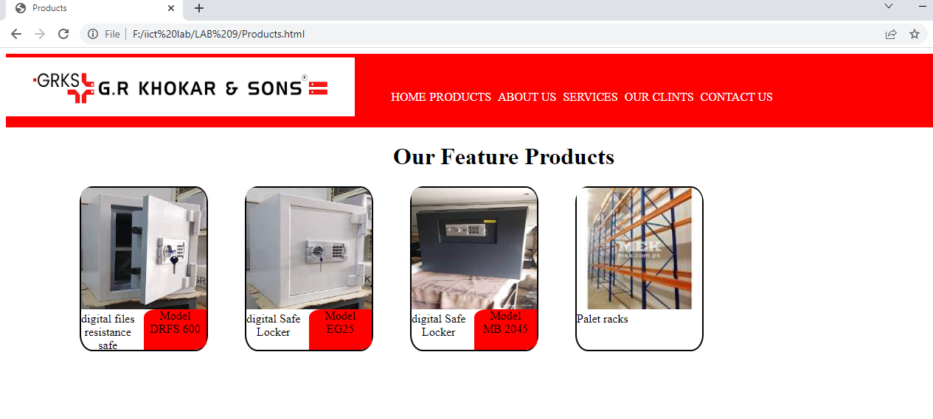

<!DOCTYPE html>

<html lang="en">

<head>

<meta charset="UTF-8">

<meta http-equiv="X-UA-Compatible" content="IE=edge">

<meta name="viewport" content="width=device-width, initial-scale=1.0">

<link rel="stylesheet" href="style.css">

<title>services</title>

</head>

<body>

<header class="header">

<nav>

<div class="navigation"><a href="html.html"> <img src="logo.png" height="80px" width="35%" style="float: left;margin-top: 5px;" ></a>

</div>

<div class="tabs" style="float: left;margin-top: 50px;" >

<a href="html.html" style="color:white;float: left;margin-left: 50px;text-decoration: none"> HOME </a>

<a href="Products.html" style="color:white;margin-left: 5px;text-decoration: none">PRODUCTS</a>

<a href="about.html" style="color:white;margin-left: 5px;text-decoration: none">ABOUT US </a>

<a href="services.html" style="color:white;margin-left: 5px;text-decoration: none">SERVICES </a>

<a href="clients.html" style="color:white;margin-left: 5px;text-decoration: none">OUR CLINTS </a>

<a href="contact.html" style="color:white;margin-left: 5px;text-decoration: none">CONTACT US </a></div>

</nav>

</header>

<h2 style="margin-top: 10px;">Fire & Theft resistance Safe</h2>

<small style="color: gray;margin-top: 5px;">we have very wide fire & theft resistance sefes. Some images of fire &<br> theft resistance safe is showing below</small>

<div style="height: 60%;width:100%;">

<img src="3.1p.jfif" height="200px" width="200px" >

<img src="3.2p.jfif" height="200px" width="200px" >

<img src="3.3p.jfif" height="200px" width="200px" ><br>

<img src="3.4p.jfif" height="200px" width="200px" >

<img src="3.5p.jfif" height="200px" width="200px" >

<img src="3.6p.jfif" height="200px" width="200px" ><br>

<img src="3.8.jfif" height="200px" width="200px" >

<img src="3.7.jfif" height="200px" width="200px" >

<img src="3.8.jfif"height="200px" width="200px" ></div>

</body>

</html>

<!DOCTYPE html>

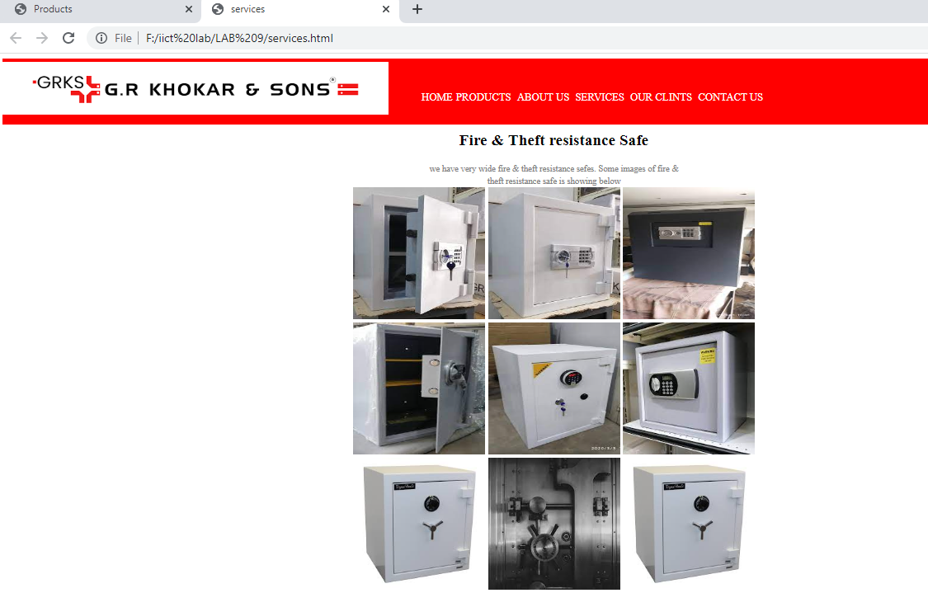

<html lang="en">

<head>

<meta charset="UTF-8">

<meta http-equiv="X-UA-Compatible" content="IE=edge">

<meta name="viewport" content="width=device-width, initial-scale=1.0">

<link rel="stylesheet" href="style.css">

<title>Our clients</title>

</head>

<body>

<header class="header">

<nav>

<div class="navigation"> <a href="html.html"><img src="logo.png" height="80px" width="35%" style="float: left;margin-top: 5px;" ></a>

</div>

<div class="tabs" style="float: left;margin-top: 50px;" >

<a href="html.html" style="color:white;float: left;margin-left: 50px;text-decoration: none"> HOME </a>

<a href="Products.html" style="color:white;margin-left: 5px;text-decoration: none">PRODUCTS</a>

<a href="about.html" style="color:white;margin-left: 5px;text-decoration: none">ABOUT US </a>

<a href="services.html" style="color:white;margin-left: 5px;text-decoration: none">SERVICES </a>

<a href="clients.html" style="color:white;margin-left: 5px;text-decoration: none">OUR CLINTS </a>

<a href="contact.html"target="_blank" style="color:white;margin-left: 5px;text-decoration: none">CONTACT US </a></div>

</nav>

</header>

<div style="float: left;margin-top: 15%;margin-left: 5%;"> <h1>Our Key Clients</h1><small>Our Clients come from cutting edge competative <br>privite companies with strong organic growth</small></div>

<div style="height:960px;width: 65%;float: right;">

<div style="float: left;"> <img src="nbp.png" height="180px" width="200px"> </div>

<div style="float: left;"> <img src="dg.png" height="180px" width="200px"> </div>

<div style="float: left;"> <img src="lkc.png" height="180px" width="200px"> </div>

<div style="float: left;"> <img src="tcs.png" height="180px" width="200px"> </div>

<div style="float: left;"> <img src="psm.jfif" height="180px" width="200px"> </div>

<div style="float: left;"> <img src="dha.jfif" height="180px" width="200px"> </div>

<div style="float: left;"> <img src="parco.jfif" height="180px" width="200px"> </div>

<div style="float: left;"> <img src="ffc.jfif" height="150px" width="200px"> </div>

<div style="float: left;"> <img src="drzia.jpg" height="200px" width="200px"> </div>

</div>

</body>

</html>

